Project Report Format
- INTRODUCTION
  - Project Overview
  - Purpose
- IDEATION PHASE
  - Problem Statement
  - Empathy Map Canvas
  - Brainstorming
- REQUIREMENT ANALYSIS
  - Customer Journey map
  - Solution Requirement
  - Data Flow Diagram
  - Technology Stack
- PROJECT DESIGN
  - Problem Solution Fit
  - Proposed Solution
  - Solution Architecture
- PROJECT PLANNING & SCHEDULING
  - Project Planning
- FUNCTIONAL AND PERFORMANCE TESTING
  - Performance Testing
- RESULTS
  - Output Screenshots
- ADVANTAGES & DISADVANTAGES
- CONCLUSION
- FUTURE SCOPE 11. APPENDIX
Source Code(if any)
Dataset Link
GitHub & Project Demo Link

INTRODUCTION

1.1 Project Overview

Startup Success Prediction is a machine learning-based analytical system developed to predict whether a startup company is likely to succeed or fail. In today’s competitive business environment, many startups are launched every year, but only a small percentage achieve long-term success. Investors and entrepreneurs often face difficulty in identifying which startups have higher chances of growth and profitability.

This project uses historical startup data such as funding amount, number of funding rounds, investor details, company category, market sector, and geographical location to analyze patterns that influence startup success. By applying machine learning algorithms like Logistic Regression, Decision Tree, and Random Forest, the system learns from past startup outcomes and builds a predictive model.

The system performs data preprocessing, feature selection, and model training to improve prediction accuracy. After training, the model can take new startup details as input and provide a prediction result indicating the probability of success.

The main aim of this project is to support investors in making data-driven investment decisions and to reduce financial risk. Instead of relying only on assumptions or intuition, this system provides analytical insights based on data.

This project also demonstrates the practical implementation of data science concepts such as data cleaning, exploratory data analysis, model evaluation, and performance testing. It bridges the gap between theoretical machine learning knowledge and real-world business applications.

Overall, Startup Success Prediction is a smart decision-support system that combines business understanding with machine learning techniques to improve investment strategies and startup evaluation processes.

1.2 Project Purpose

The main purpose of this project is to develop a machine learning-based system that predicts the success or failure of a startup company using historical data. Many investors face financial losses because they invest in startups without proper data analysis. This project aims to reduce that risk by providing a data-driven prediction model.
The system helps investors, entrepreneurs, and business analysts evaluate startup potential before making important financial decisions. By analyzing key factors such as funding amount, number of funding rounds, industry category, and investor information, the model identifies patterns that influence startup success.
Another important purpose of this project is to apply data science and machine learning concepts to a real-world business problem. It provides practical experience in data preprocessing, feature selection, model training, evaluation, and performance testing.
This project also aims to:
- Improve decision-making using analytical insights.
- Increase investment success rate.
- Provide a simple and easy-to-use prediction system.
- Demonstrate how machine learning can support business growth.
Overall, the purpose of this project is to combine technology and business intelligence to create a reliable startup evaluation system.

IDEATION PHASE

2.1 Problem Statement
In today’s rapidly growing startup ecosystem, thousands of new startups are launched every year. However, only a small percentage of them achieve long-term success, while many fail due to financial, operational, or market-related challenges. Investors and venture capitalists often face difficulty in identifying which startups have strong potential for growth and profitability.
Most investment decisions are made based on assumptions, experience, or limited analysis. This increases the risk of financial loss and poor investment outcomes. There is a lack of a reliable, data-driven system that can analyze multiple business factors and predict the probability of startup success.
The challenge is to design and develop a machine learning-based prediction system that can analyze historical startup data and identify patterns associated with successful and unsuccessful startups. The system should be able to take relevant input features such as funding amount, number of funding rounds, industry category, location, and investor details, and predict whether a startup is likely to succeed or fail.
Therefore, the problem is to build an accurate and efficient predictive model that reduces investment risk and supports better decision-making using data analytics and machine learning techniques.

2.2 Empathy Map Canvas

In this project, we are empathizing with investors and venture capitalists who invest in startup companies. They are responsible for selecting promising startups and making important financial decisions. Their main goal is to invest in startups that have strong growth potential and generate high returns. At the same time, they must avoid risky investments that may lead to financial loss.
When we analyze what they hear, investors often hear that startups are highly risky. They receive advice from financial experts, market analysts, and colleagues about investment opportunities. They also hear news about startup failures, economic changes, and market trends. These external opinions influence their thinking and decision-making process.
In terms of what they see, investors observe many startups entering the market every year. They see high competition across industries, funding announcements, and success stories of unicorn companies. They also see reports showing high startup failure rates. This makes it difficult for them to clearly identify which startup is truly promising.
When we understand what they think and feel, investors often experience fear of financial loss and uncertainty about future growth. They may feel confused due to the large number of investment options available. They also feel pressure to choose the right startup because their decision directly affects returns. At the same time, they want clear success probability, reliable data-based decision support, and higher return on investment. They seek confidence and security before investing money.
In their actions, investors usually analyze financial reports, study funding history, compare multiple startups, and evaluate business models. They discuss opportunities with their team before making final decisions. They carefully calculate potential return on investment and risk factors.

2.3 Brainstroming
In the beginning, we clearly defined our problem statement. The main goal of our project is to develop a machine learning model that predicts startup success using factors like funding amount, number of funding rounds, founder details, market category, and financial data. Many startups fail because investment decisions are not based on proper data analysis. Investors need a system that can estimate success probability before investing. So, our project aims to build a data-driven solution to reduce risk and improve decision-making.
During the brainstorming session, our team generated many ideas to solve this problem. We discussed analyzing startup funding data, studying revenue growth patterns, comparing startups by industry and location, and identifying important success factors. We also planned to build a success probability system and risk scoring model. From a technical side, we decided to apply machine learning algorithms such as Logistic Regression, Random Forest, and XGBoost to improve prediction accuracy. We also considered creating a web dashboard to display the results.
After brainstorming, we grouped similar ideas into categories. The first group focused on startup data analysis, including funding analysis and industry comparison. The second group focused on machine learning model development, including model building, preprocessing, and feature importance analysis. The third group was about risk and success evaluation, where we planned to classify startups based on risk level. The final group focused on developing a web application with a user-friendly interface to show prediction results.
Finally, we prioritized the ideas based on importance and feasibility. Building the startup success prediction model and generating success probability output were considered the highest priority. Developing the web dashboard and applying core machine learning algorithms were also important and feasible. Advanced improvements like complex modeling and extra UI styling were given lower priority. This prioritization helped us focus on delivering a working and effective system within the project timeline.

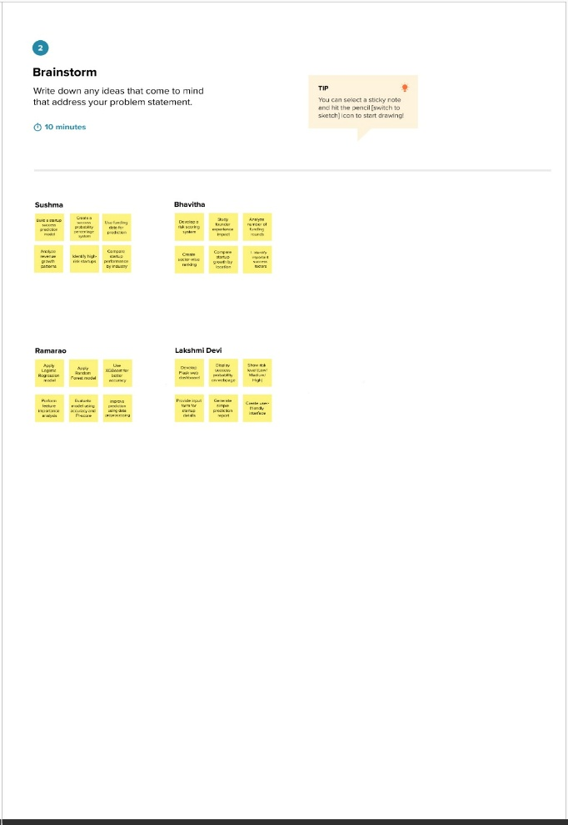
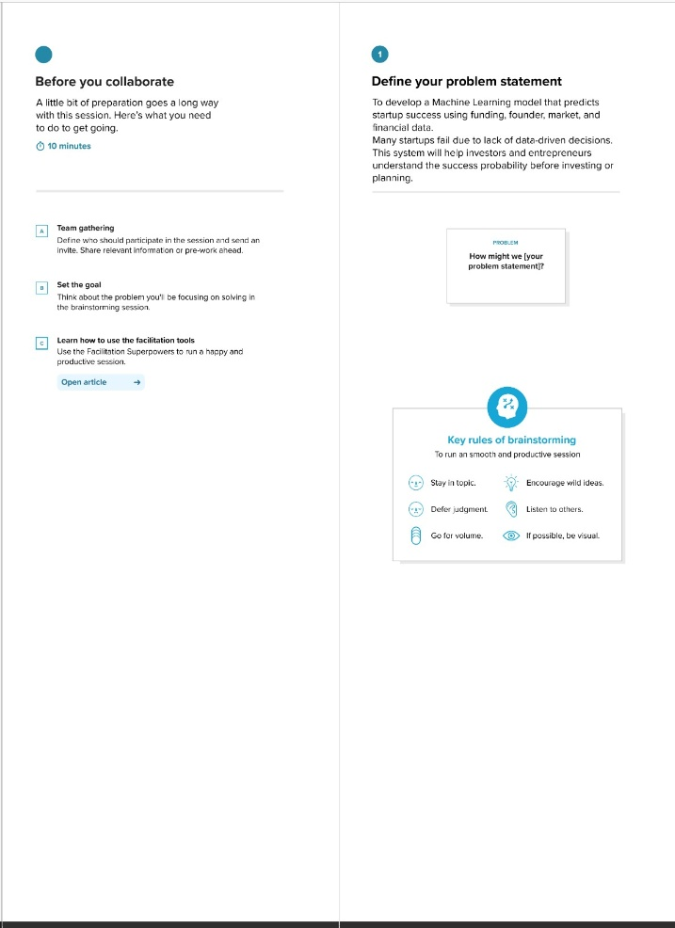
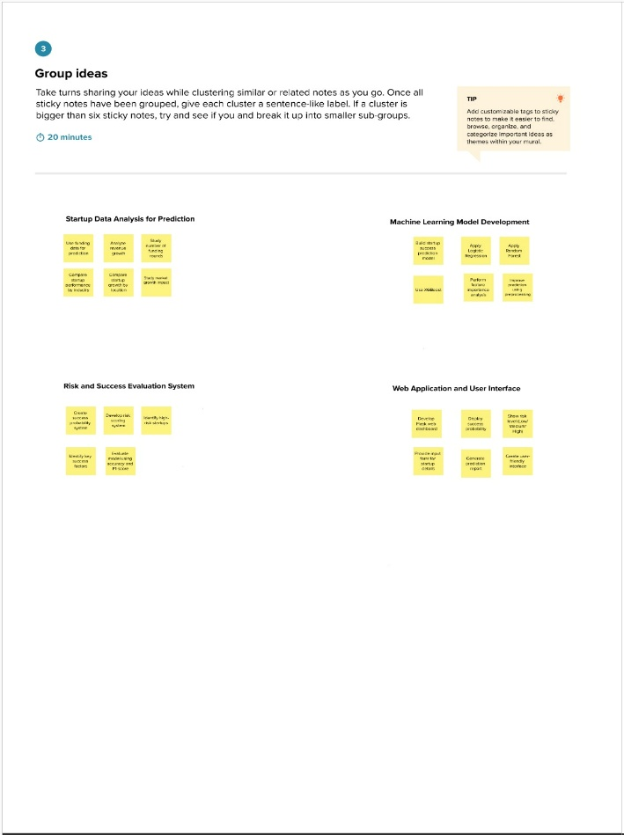
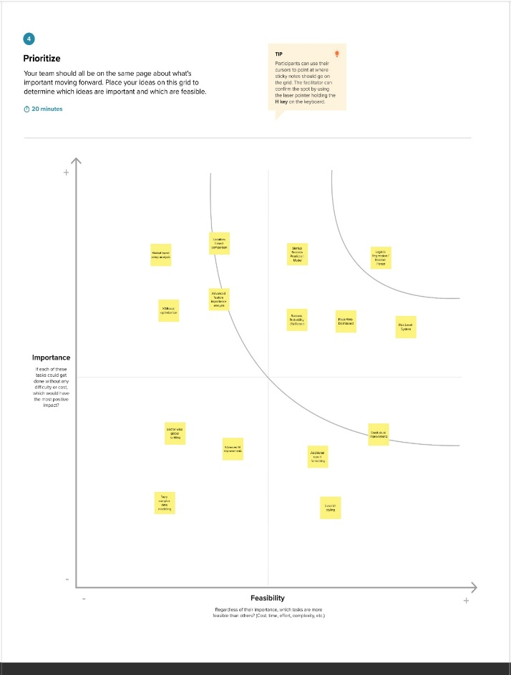

3.REQUIREMENTS ANALYSIS

3.1 Customer Journey map
The customer journey begins when an investor realizes the need to evaluate startup success before investing. In the Entice stage, the investor searches for startup prediction tools, explores data-driven investment solutions, and learns about AI-based analysis systems. In the Enter stage, the investor visits the web application, reads about how the machine learning model works, and understands what information needs to be provided. At this stage, the main goal is to understand the system clearly and feel confident about using it.
In the Engage stage, the investor submits startup details such as funding, industry, and other financial data. The system processes the data using the machine learning model and generates the success probability along with the risk level (Low/Medium/High). The investor views key factors affecting success and analyzes the prediction results. Positive moments in this stage include fast results and clear success percentage display, while negative moments may include confusion about technical terms or doubts about model accuracy.
In the Exit stage, the investor reviews the prediction result and decides whether to invest. In the Extend stage, the investor may use the tool again to compare multiple startups, apply insights in portfolio planning, and make better investment decisions. Overall, the journey shows that investors want a simple, accurate, and easy-to-use system that reduces risk and supports confident, data-driven investment decisions.

3.2 Solution Requirements

The Prosperity Prognosticator is a web-based application developed using Python and Flask that predicts the success probability of startups using Machine Learning techniques. The system allows users such as investors and entrepreneurs to register, log in, and enter startup details including funding amount, revenue, industry type, market size, and growth rate. The application processes the entered data using a trained Machine Learning model and generates a success probability percentage along with a risk level (Low, Medium, or High). The results are displayed clearly on a dashboard, and users can download a report for further analysis.
The system is designed to be simple, user-friendly, and efficient. It ensures secure authentication, encrypted password storage, and proper validation of user inputs. The prediction results are generated quickly to provide real-time insights for better decision-making. The system stores user data and prediction history in a structured database, allowing future reference and analysis.
In addition, the architecture supports scalability and future improvements. The Machine Learning model can be retrained with new data to improve accuracy, and the application can be deployed on a local server or cloud platform for 24/7 accessibility. The overall solution focuses on providing reliable, data-driven insights to reduce investment risk and support informed startup decision-making.

3.3 Data Flow Diagram

The diagram represents a student registration and test registration workflow system. In this system, the Student is the primary user who initiates the process by submitting a registration request. The request is sent to the Check Request process, where the system verifies the submitted details. After verification, the request is either forwarded for confirmation or directed to the registration process. This ensures that only valid and approved student information moves forward in the system.
Once the request is approved, the system proceeds with Register Students, where the student’s details are officially recorded in the system database. After successful registration, the student can proceed to Tests Registration, allowing them to enroll in available tests. The Confirm Registration process ensures that the student receives confirmation of successful registration and eligibility for tests.
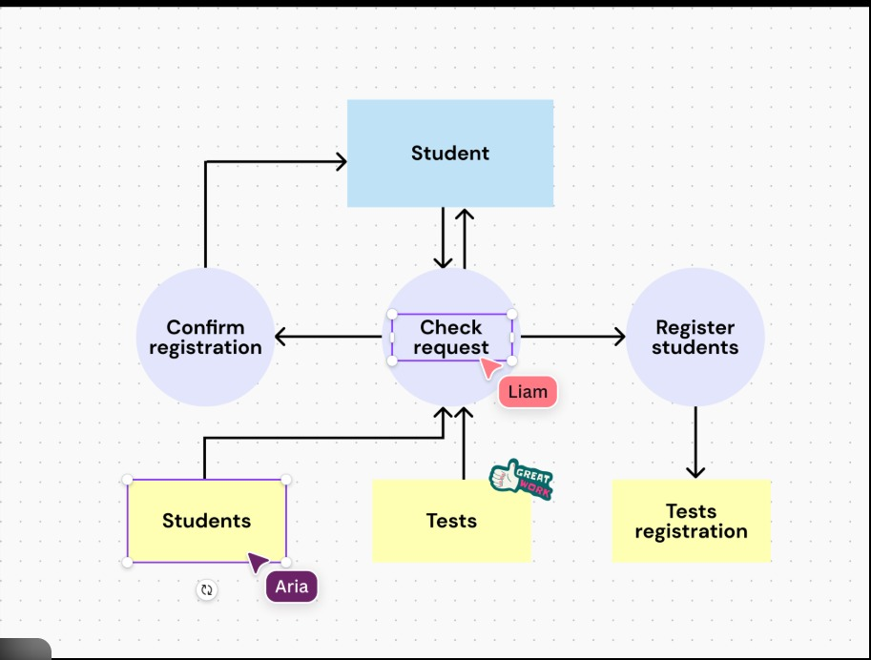
The diagram also shows interaction between system components such as Students, Tests, and the verification process. The flow of information moves between these components to maintain proper validation, record management, and test enrollment. Overall, the system ensures a structured and organized registration process with verification, confirmation, and test allocation stages.

3.4 Technology Stack

The Prosperity Prognosticator system is developed using a modern and efficient technology stack to ensure accurate predictions and smooth user interaction. The frontend of the application is built using HTML, CSS, and Bootstrap to provide a clean and user-friendly interface. This allows investors and entrepreneurs to easily enter startup details and view prediction results in a structured dashboard format. The backend of the system is developed using Python with the Flask framework, which handles user authentication, data validation, and communication between the frontend and the Machine Learning model.
The Machine Learning component is implemented using Scikit-learn along with libraries such as Pandas and NumPy for data preprocessing and analysis. Models such as Logistic Regression and Random Forest are used to predict the success probability of startups based on input features like funding amount, revenue, and market size. The trained model is stored as a serialized file (.pkl) and integrated into the Flask application for real-time predictions.
For data management, the system uses SQLite or MySQL to store user information and prediction history securely. The application can be deployed on a local server or cloud platforms such as Render or AWS for online accessibility. Overall, the selected technology stack ensures scalability, security, fast performance, and reliable prediction results for data-driven decision-making.

4.PROJECT DESIGH

4.1 Problem Solution Fit

The main problem identified in this project is that investors face difficulty in predicting whether a startup will succeed or fail before investing. Many investment decisions are based on assumptions, limited data, or personal judgment, which increases financial risk. There is no simple and reliable system that provides a clear success probability using historical startup data.
Our proposed solution directly addresses this problem by developing a machine learning-based prediction system. The system analyzes important factors such as funding amount, number of funding rounds, industry category, and other business-related data. By training the model on historical startup data, it learns patterns associated with successful and unsuccessful startups. Based on this analysis, it provides a success probability and risk level classification for new startups.
This solution fits the problem because it reduces uncertainty, supports data-driven decision-making, and provides clear analytical insights. Investors can use the prediction results to compare startups, evaluate risk, and make confident investment decisions. Therefore, the system effectively bridges the gap between business risk and data-based investment planning.
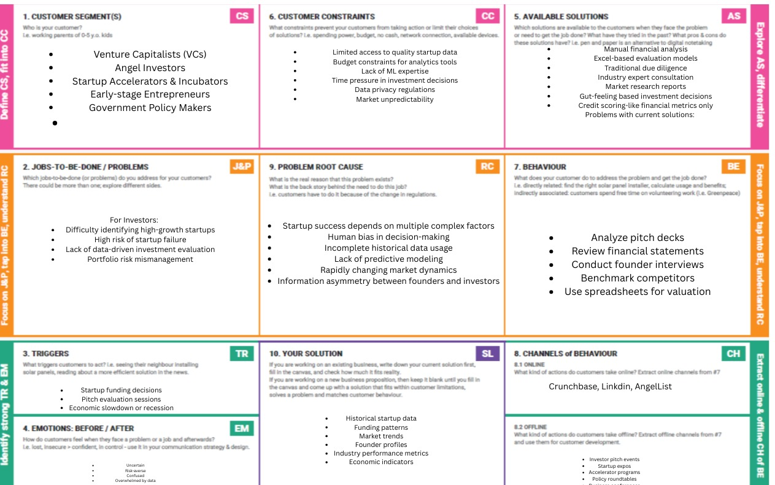

4.2 Proposed Soluriton

The proposed solution is to develop a machine learning-based Startup Success Prediction System that analyzes startup-related data and predicts the probability of success. The system uses historical startup data such as funding amount, number of funding rounds, industry type, location, and other financial indicators to train the prediction model.
The solution includes data preprocessing, feature selection, and model training using algorithms like Logistic Regression and Random Forest. After training, the model can take new startup details as input and generate a success probability along with a risk level classification (Low, Medium, High). This helps users clearly understand the startup’s potential performance.
To make the system user-friendly, a web-based interface is developed where users can enter startup details and view prediction results instantly. The system also displays key factors influencing the prediction to improve transparency and trust. Overall, the proposed solution provides a simple, accurate, and data-driven tool that supports better investment decision-making.

4.3 Solution Architecture

The solution architecture of the Startup Success Prediction system is designed in a structured and organized manner. The system consists of four main components: Data Collection, Data Processing, Machine Learning Model, and User Interface.
First, the historical startup dataset is collected from reliable sources. This data includes important features such as funding amount, number of funding rounds, industry type, and other business-related information. In the next step, data preprocessing is performed. This includes cleaning missing values, encoding categorical data, and selecting important features required for model training.
After preprocessing, the cleaned data is used to train machine learning algorithms such as Logistic Regression and Random Forest. The trained model analyzes input startup details and generates a success probability along with a risk level classification. The performance of the model is evaluated using metrics like accuracy and F1-score to ensure reliability.
Finally, the trained model is integrated into a web-based application. Users can enter startup details through an input form, and the system processes the data and displays the prediction results instantly. This architecture ensures smooth data flow, accurate prediction, and an easy-to-use interface for investors and business analysts.

5. PROJECT PLANNING AND SCHEDULING

5.1 Project Planning
The Prosperity Prognosticator project was planned using a structured and phased development approach to ensure timely completion and quality output. The project was divided into multiple stages including requirement analysis, system design, data collection, model development, web application development, testing, and deployment. Each stage was assigned specific responsibilities among the four team members to ensure effective collaboration and balanced workload distribution.
During the planning phase, the team first identified the problem statement and defined functional and non-functional requirements. After finalizing the requirements, the system architecture, data flow diagrams, and database design were prepared. The Machine Learning model was developed and tested separately before integrating it into the Flask-based web application. Regular team meetings were conducted to track progress and resolve technical challenges.
The project timeline was carefully scheduled to complete development within the academic semester. Testing and validation were performed to ensure model accuracy and system reliability. Proper documentation was maintained throughout the project to support implementation, evaluation, and final submission. The planning approach ensured systematic execution, efficient resource utilization, and successful completion of the project objectives.

5.2 Project Scheduling
The Prosperity Prognosticator project was scheduled in a structured manner to ensure timely completion within the academic semester. The project timeline was divided into different phases including requirement analysis, system design, data collection, model development, web application development, testing, and final deployment. Each phase was assigned a specific time duration and clear deliverables to maintain steady progress.
Initially, the team focused on gathering requirements and defining the problem statement. After finalizing the design and architecture, the data preprocessing and Machine Learning model development phase was carried out. Once the prediction model was trained and tested for accuracy, it was integrated into the Flask-based web application. The development phase was followed by system testing to ensure proper functionality, security, and performance.
Regular team discussions were conducted to review milestones and track progress against the schedule. Buffer time was included to handle unexpected challenges or improvements. The structured scheduling approach helped in maintaining coordination among team members and ensured successful completion of the project within the planned timeline.

6. FUNCTIONAL AND PERFORMANCE TESTING

6.1 Functional Testing

Functional testing is performed to ensure that all parts of the system are working correctly according to the requirements. In this project, we tested whether the system correctly accepts user input such as funding amount, industry type, and other startup details. We verified that the input data is properly processed and sent to the machine learning model without errors.
We also tested whether the system correctly generates the success probability and risk level classification after processing the data. The web interface was checked to ensure that it displays results clearly and accurately. Error handling was tested by entering invalid or incomplete data to confirm that the system responds properly without crashing.

6.2 Performance testing

Performance testing was conducted to evaluate the efficiency and accuracy of the machine learning model. The dataset was divided into training and testing sets to measure how well the model performs on unseen data. Metrics such as accuracy, precision, recall, and F1-score were calculated to evaluate prediction performance.
The system was also tested for response time to ensure that predictions are generated quickly after user input. The results showed that the model provides fast and reliable predictions with satisfactory accuracy. This confirms that the system performs efficiently and meets the project requirements.

7. RESULT

8.ADVANTAGES AND DISADVANTAGES

8.1 Advantages

- Provides data-driven prediction of startup success probability.
- Helps investors reduce financial risk before investing.
- Generates quick and real-time results using Machine Learning.
- Simple and user-friendly web interface built with Flask.
- Model can be updated with new data to improve accuracy over time.

8.2 disadvantages
- Prediction accuracy depends on quality of training data.
- Cannot guarantee 100% correct results (probability-based output).
- Requires regular model updates and maintenance.
- External economic or market changes may affect prediction reliability.
- Incorrect user input data may lead to wrong predictions.
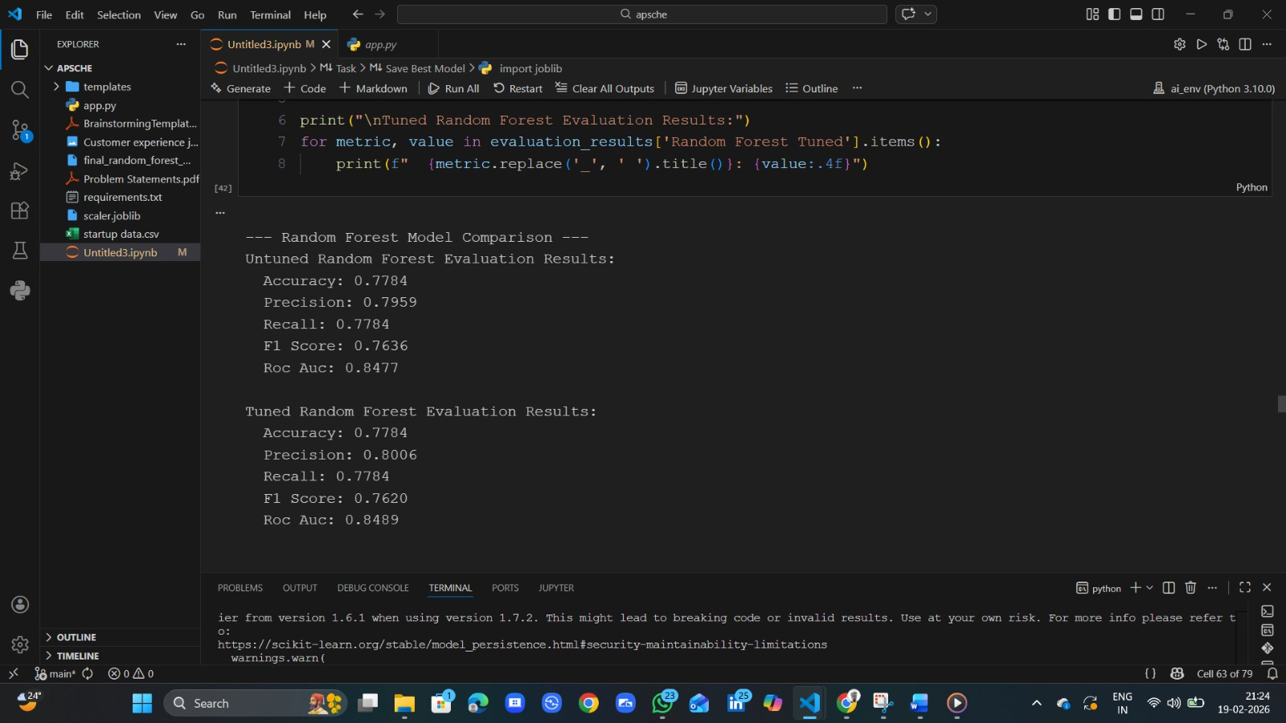
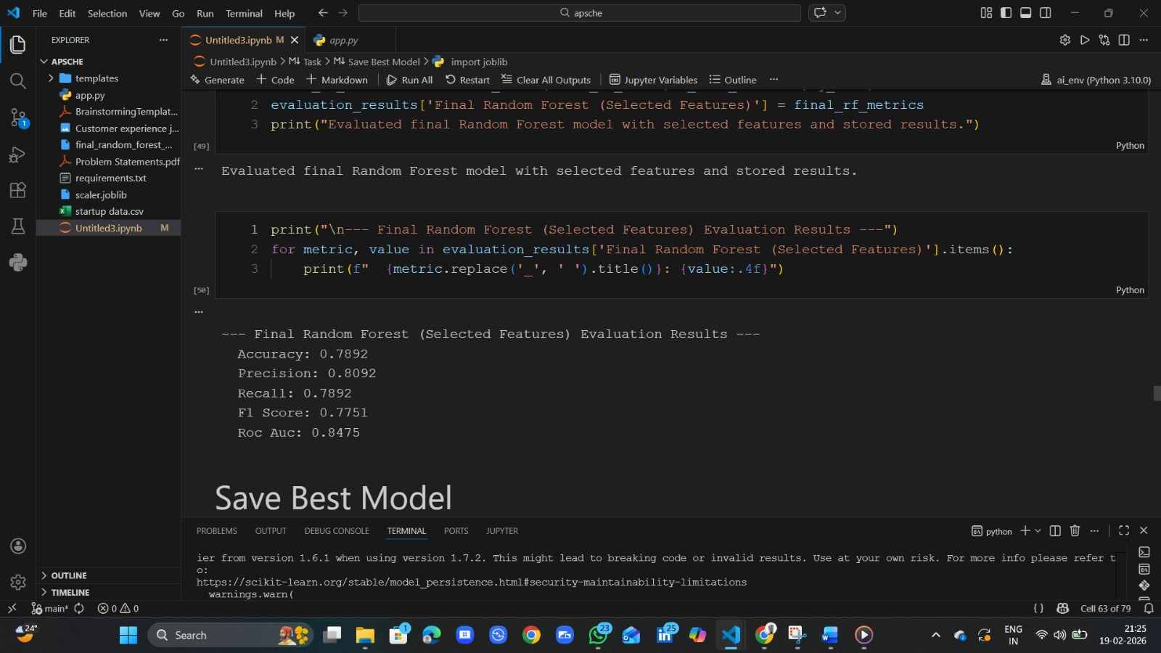
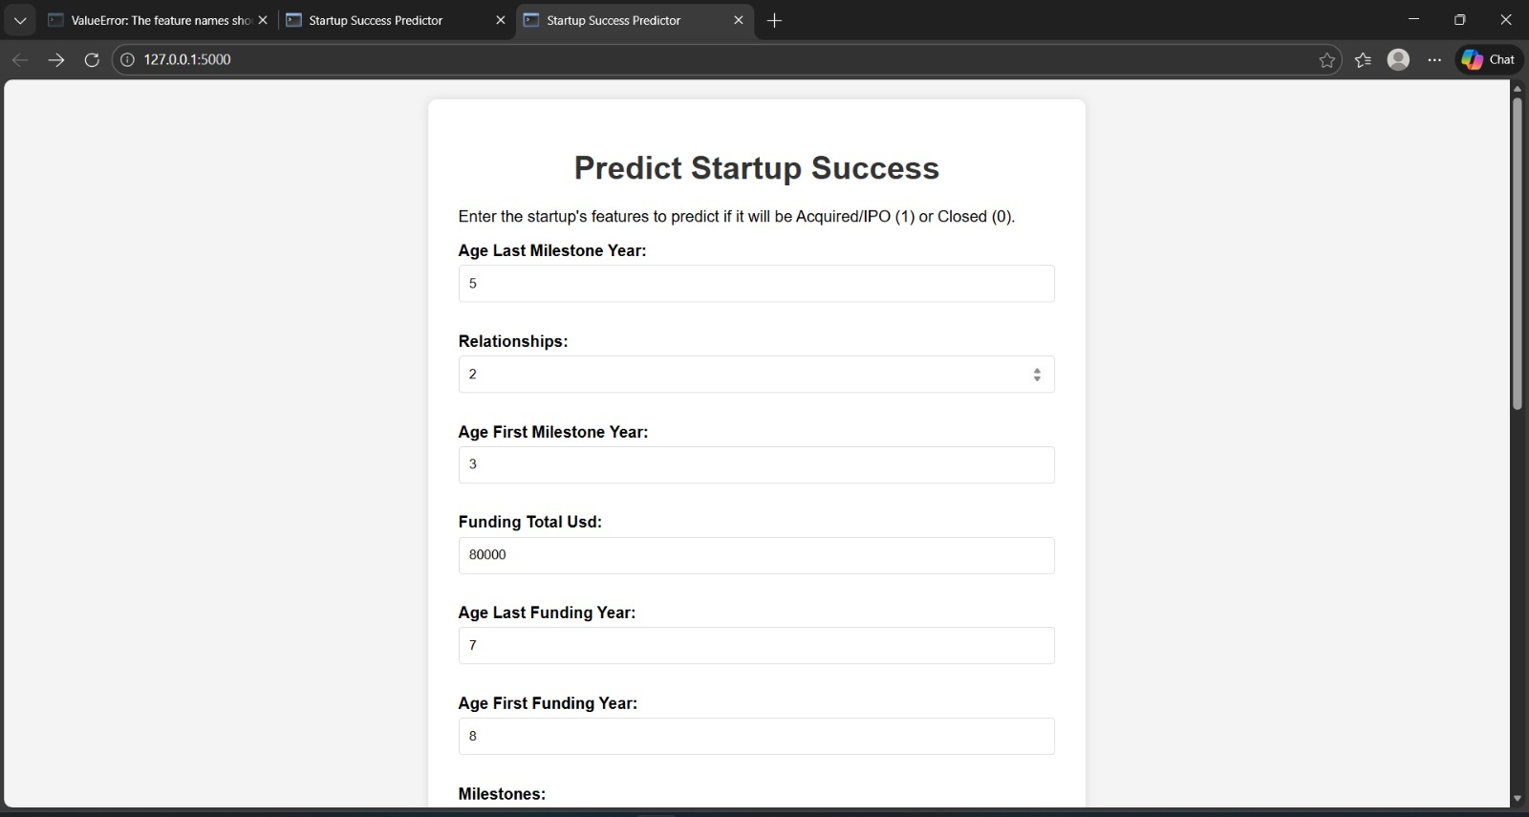
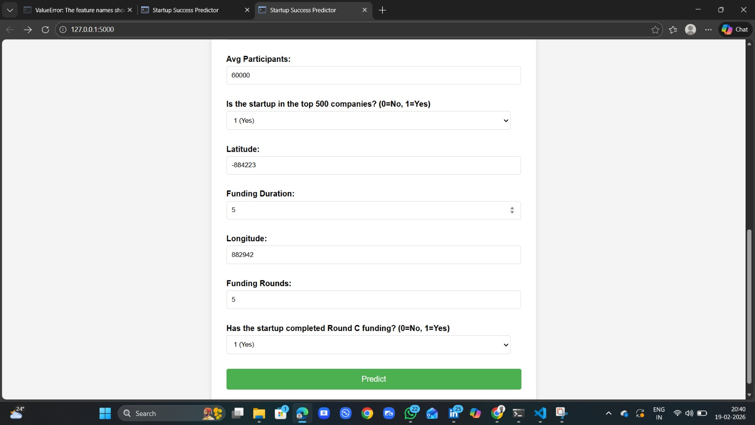
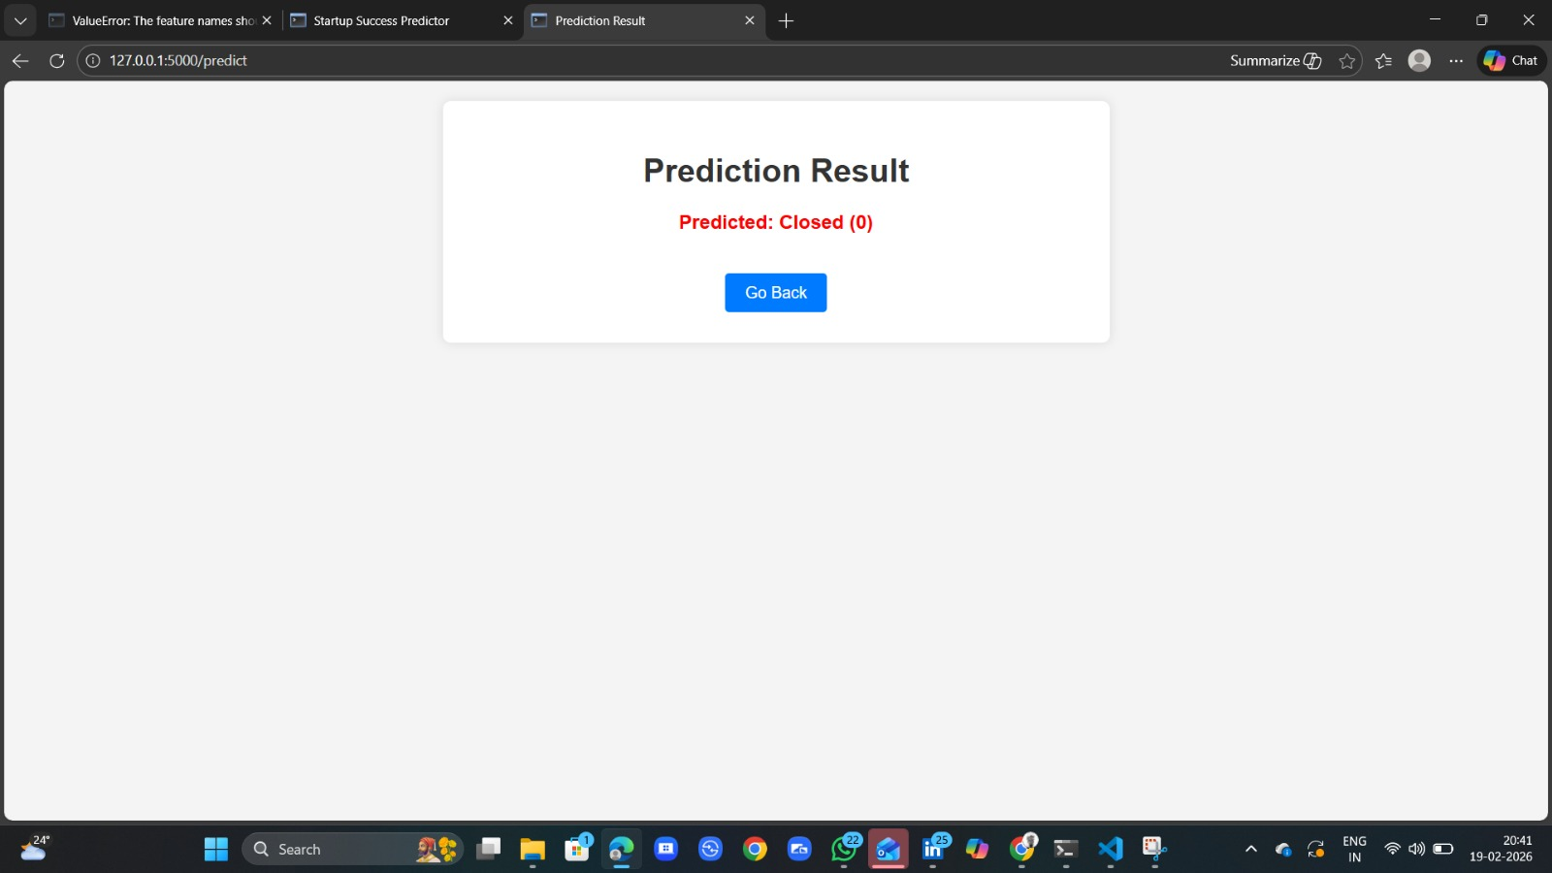
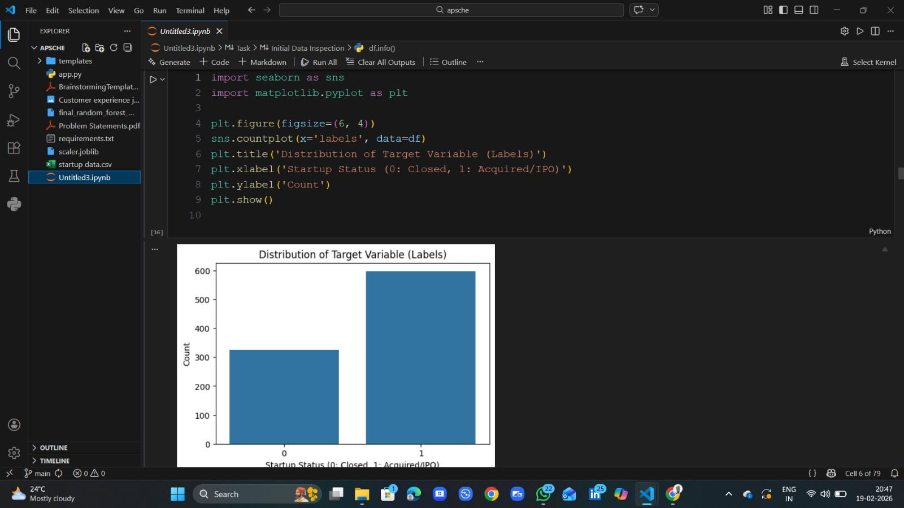
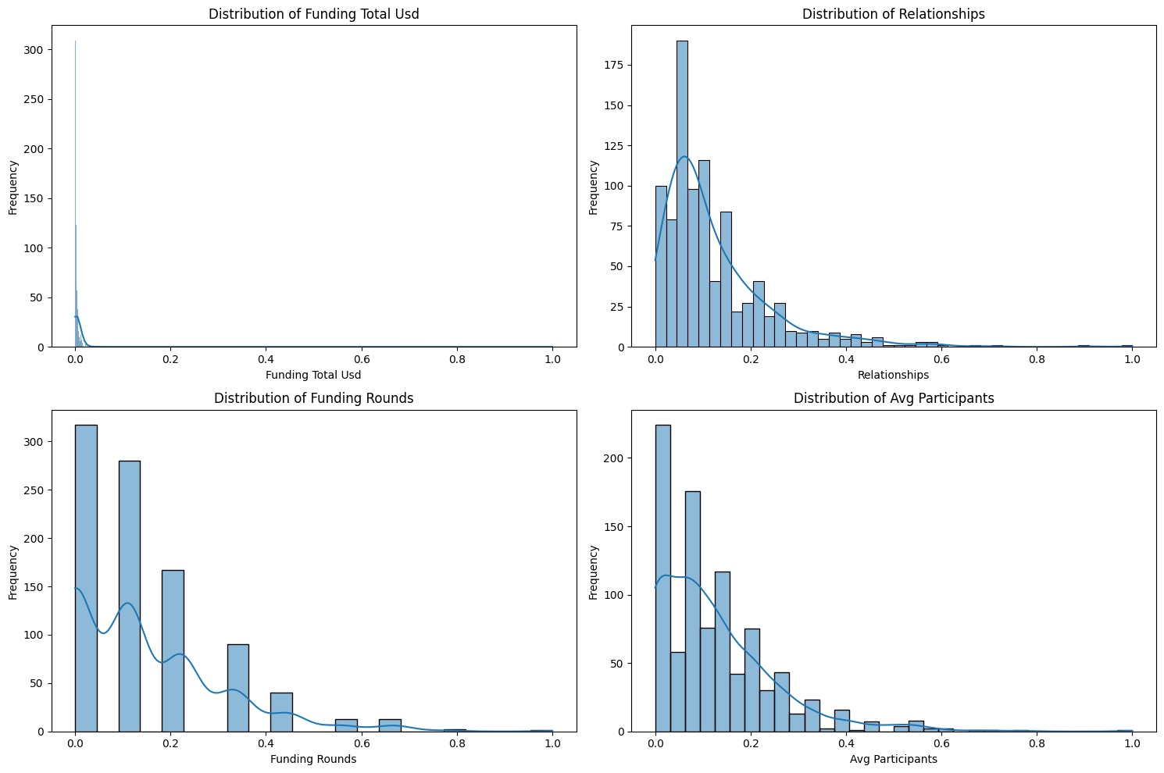
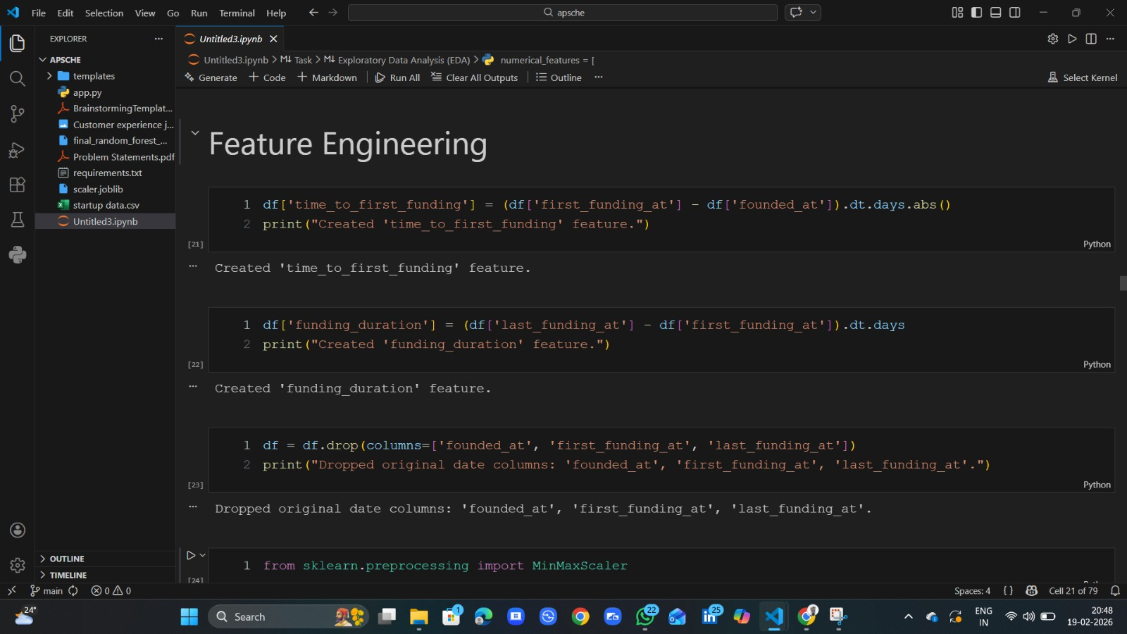

CONCLUSION

The Startup Success Prediction project successfully demonstrates how machine learning can be used to solve real-world business problems. In this project, we developed a predictive system that analyzes historical startup data and estimates the probability of success. By using important features such as funding amount, number of funding rounds, and industry category, the model identifies patterns that influence startup growth.
The system helps investors and business analysts make better decisions by providing data-driven insights instead of relying only on assumptions. Through proper data preprocessing, model training, and performance evaluation, we achieved satisfactory prediction accuracy. The web-based interface makes the system easy to use and accessible.
Overall, this project reduces investment risk and improves decision-making efficiency. It also provides practical experience in applying data science and machine learning techniques to real-world applications. The project proves that predictive analytics can play an important role in supporting business investment strategies.

FURTURE SCOPE
The Startup Success Prediction project can be further improved in many ways in the future. One possible improvement is to use advanced machine learning and deep learning algorithms to increase prediction accuracy. Models such as Gradient Boosting, XGBoost, or Neural Networks can be implemented to enhance performance.
Another future enhancement is to include real-time startup data from live business platforms. This will allow the system to provide updated and more accurate predictions based on current market conditions. Additional features such as revenue growth rate, customer acquisition data, and social media trends can also be included to improve analysis.
The project can also be expanded into a full-scale web or mobile application with advanced visualization dashboards. Features like startup comparison, detailed risk reports, and portfolio analysis tools can be added. In the future, this system can be used not only by investors but also by entrepreneurs to evaluate and improve their business strategies.

APPENDIX

Data set link: https://www.kaggle.com/datasets/manishkc06/startup-success-prediction

Github link: https://github.com/Satyagabu7/prosperity-prognosticator-machine-learning-for-startup-success

Demo Video link: https://drive.google.com/file/d/1J0X97EMjrWkotfNs5TrSR3gURhh-bFOS/view?usp=drive_link

